November 22, 2010

To Our Sponsors:

Massachusetts DeMolay, a 501(c)3 charitable trust is seeking your support in sponsoring our “Awake-A-Thon” program on February 19-20th at the Longfellow Club in Natick.

DeMolay is an organization for young men between the ages of 12 and 21. DeMolay members run the show; they decide what they want to do and when they want to do it. Adult advisors exist to give advice, to provide rides and to make sure everything the members want to do is safe and legal!

DeMolay is built on general principles designed to teach its members important life skills such as leadership, respect for themselves and others, and patriotism. Members are encouraged to abide by these principles; advisors and older members lead by example and teach these principles by deeds, not words.

The Awake-A-Thon is designed to provide a wholesome opportunity for learning and
constructive entertainment for our members in a healthy and supervised environment. Over 300 members are expected to participate. Your donation of $100 for an advertisement, which will appear on the back of our t-shirt, will help subsidize the cost of the event. Your ad will be seen not only by those who attend, but by the parents and friends of the members of this community.

Thank you in an advance for your consideration, we truly appreciate your support!

Sincerely,

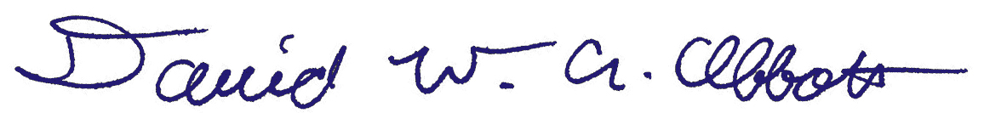

David W. A. Abbott
State Master Councilor
Massachusetts DeMolay

